# IMPORTING CSV FILE FOR PREPROCESSING

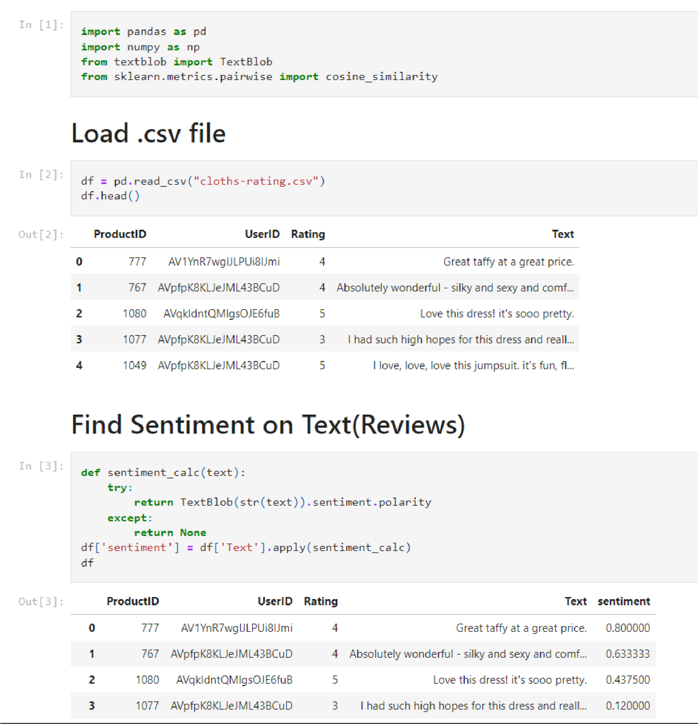

**SENTIMENT**

**ANALYSIS**

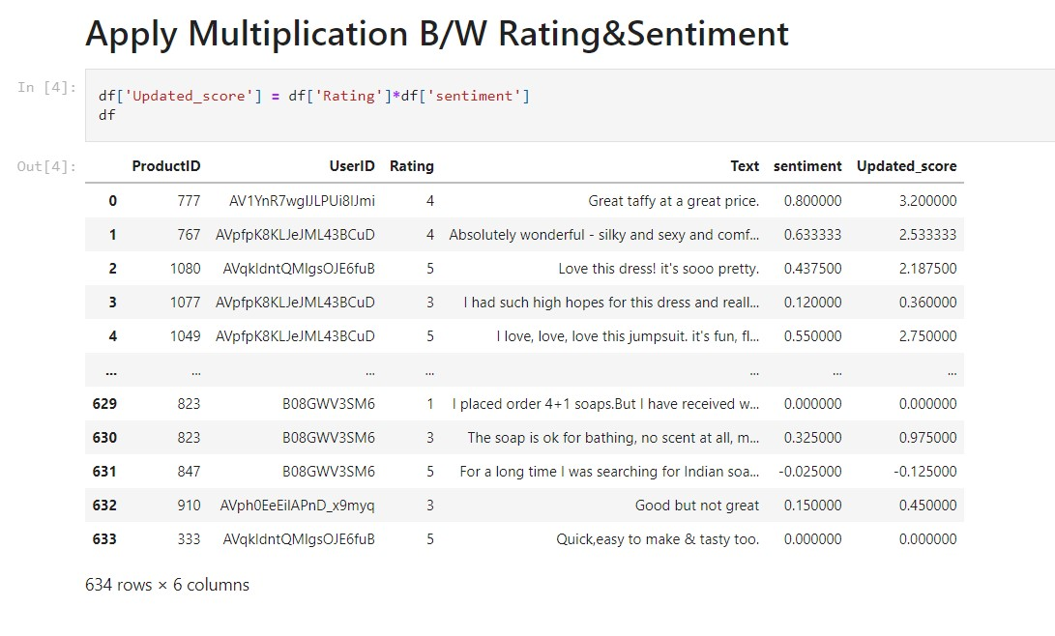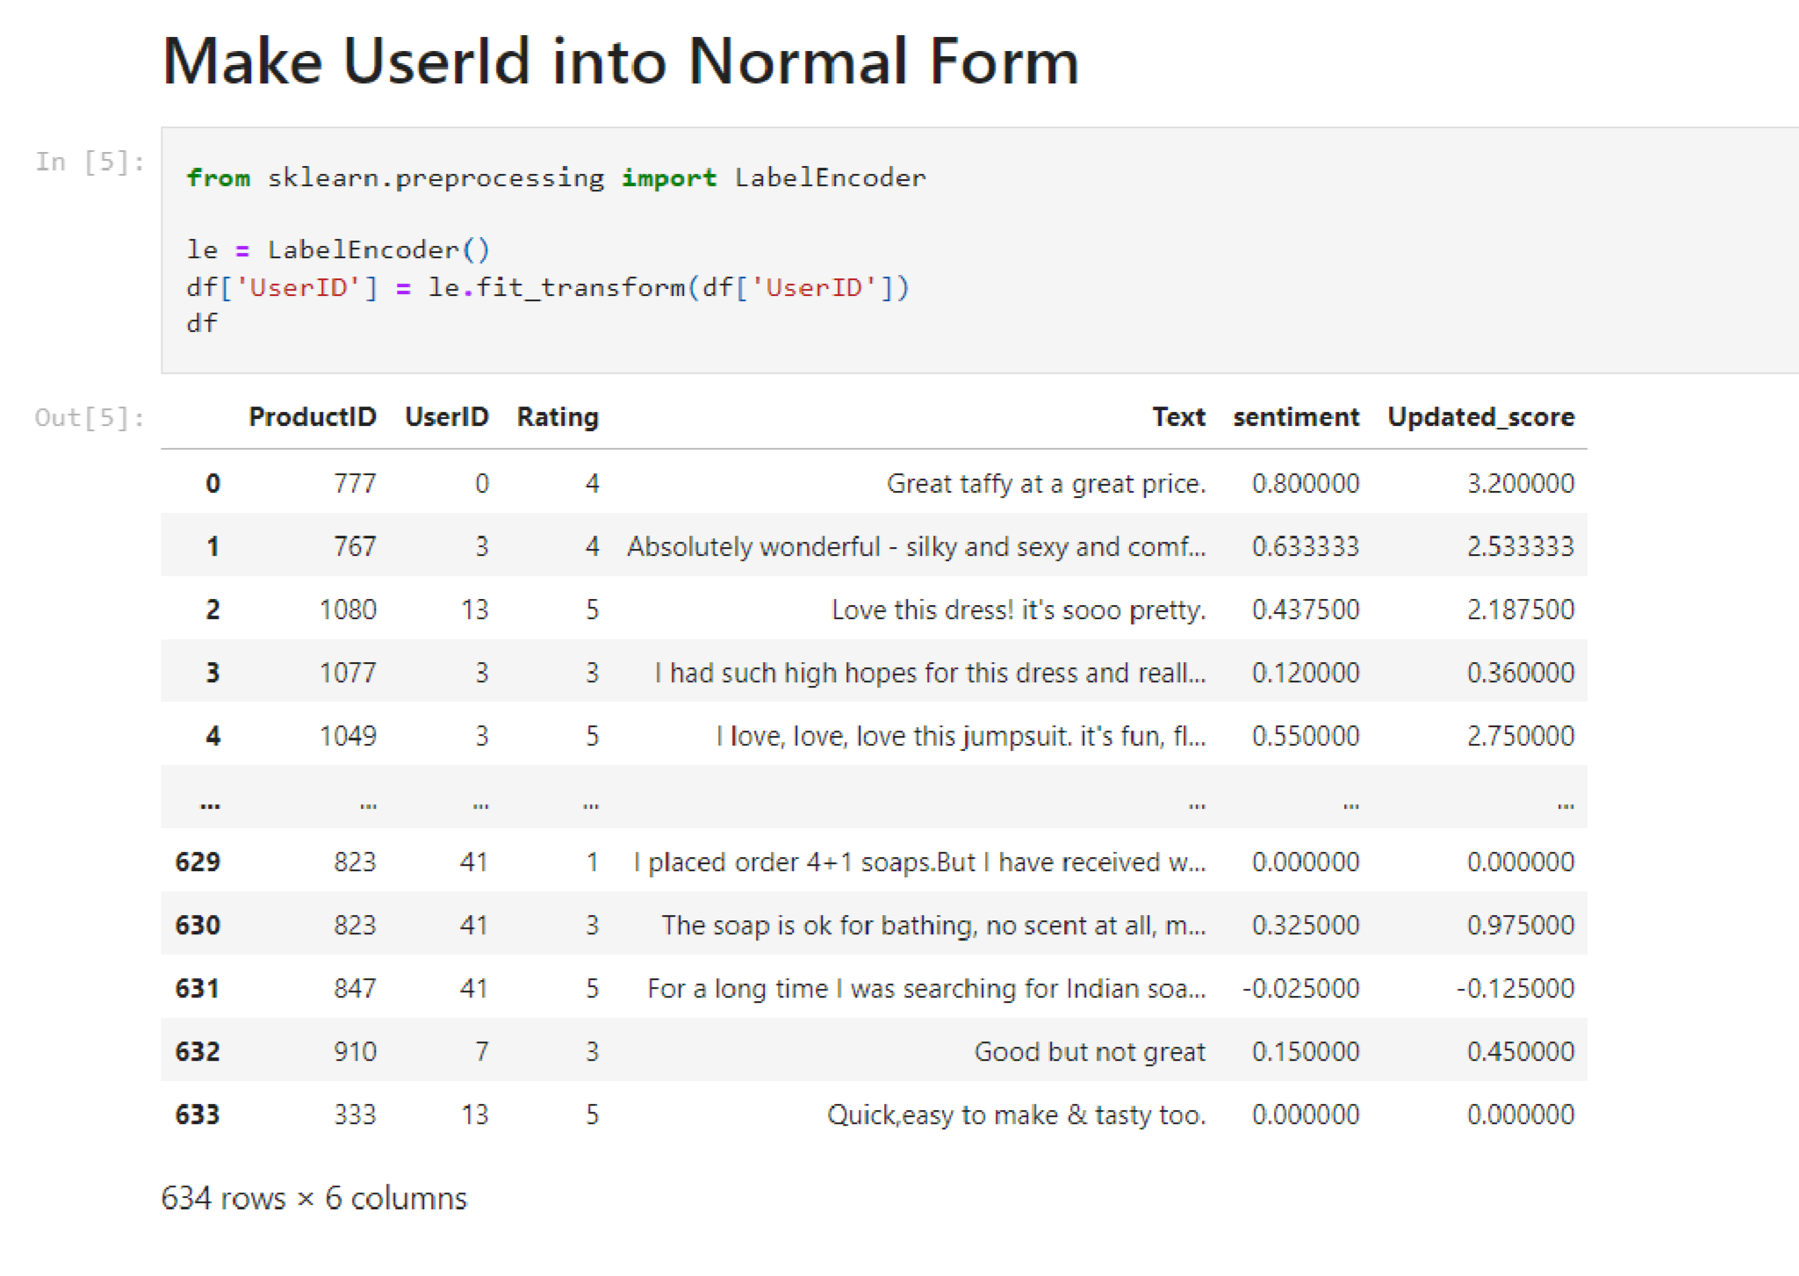

# CREATING FUNCTION FOR CLASSIFICATION

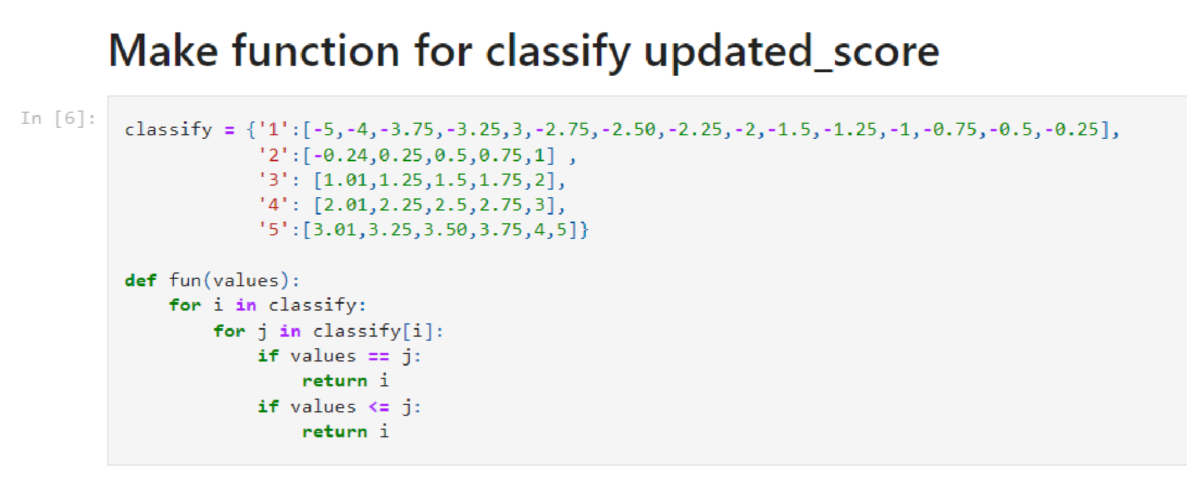

# APPLYING FUNCTION ON DATASET

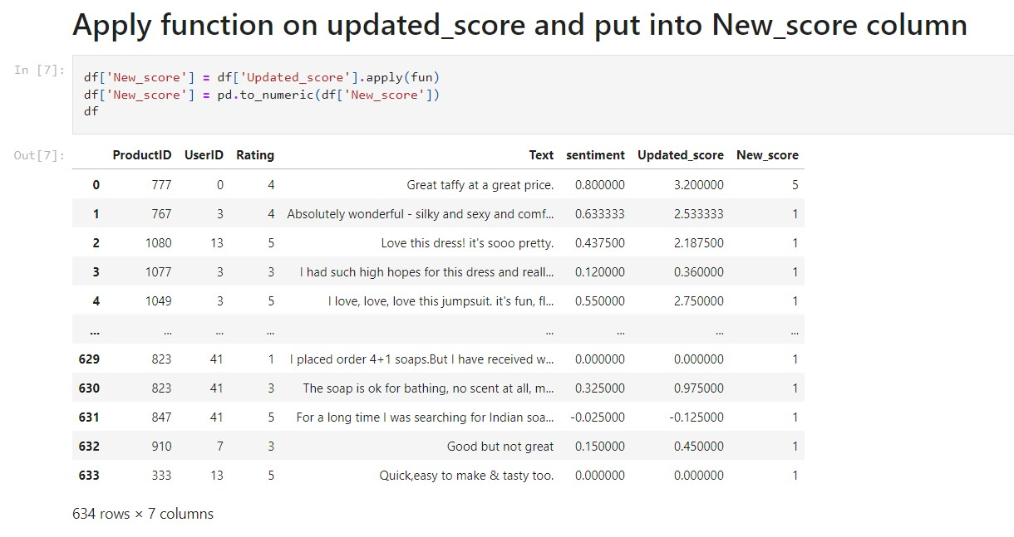

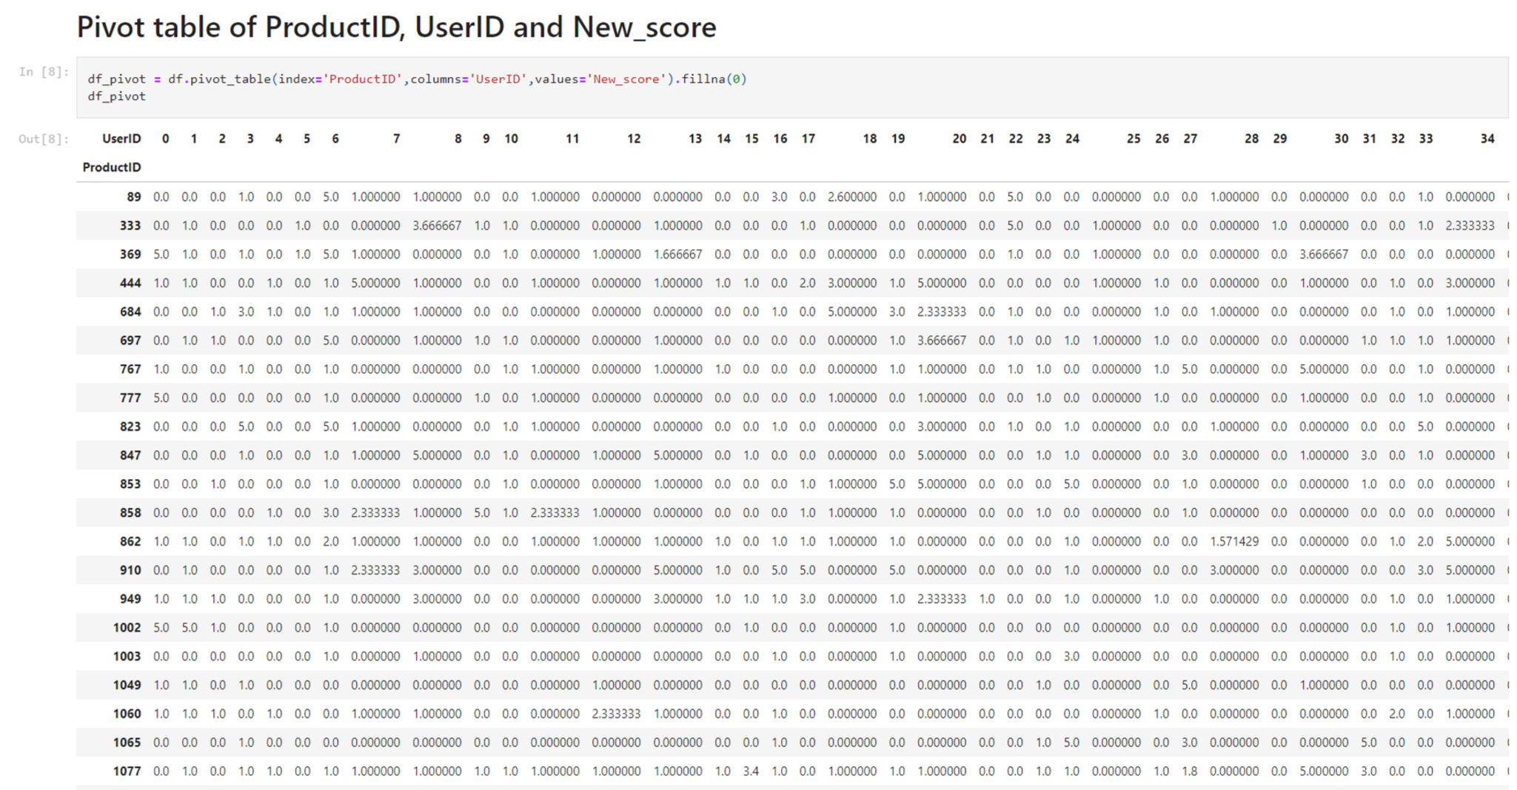

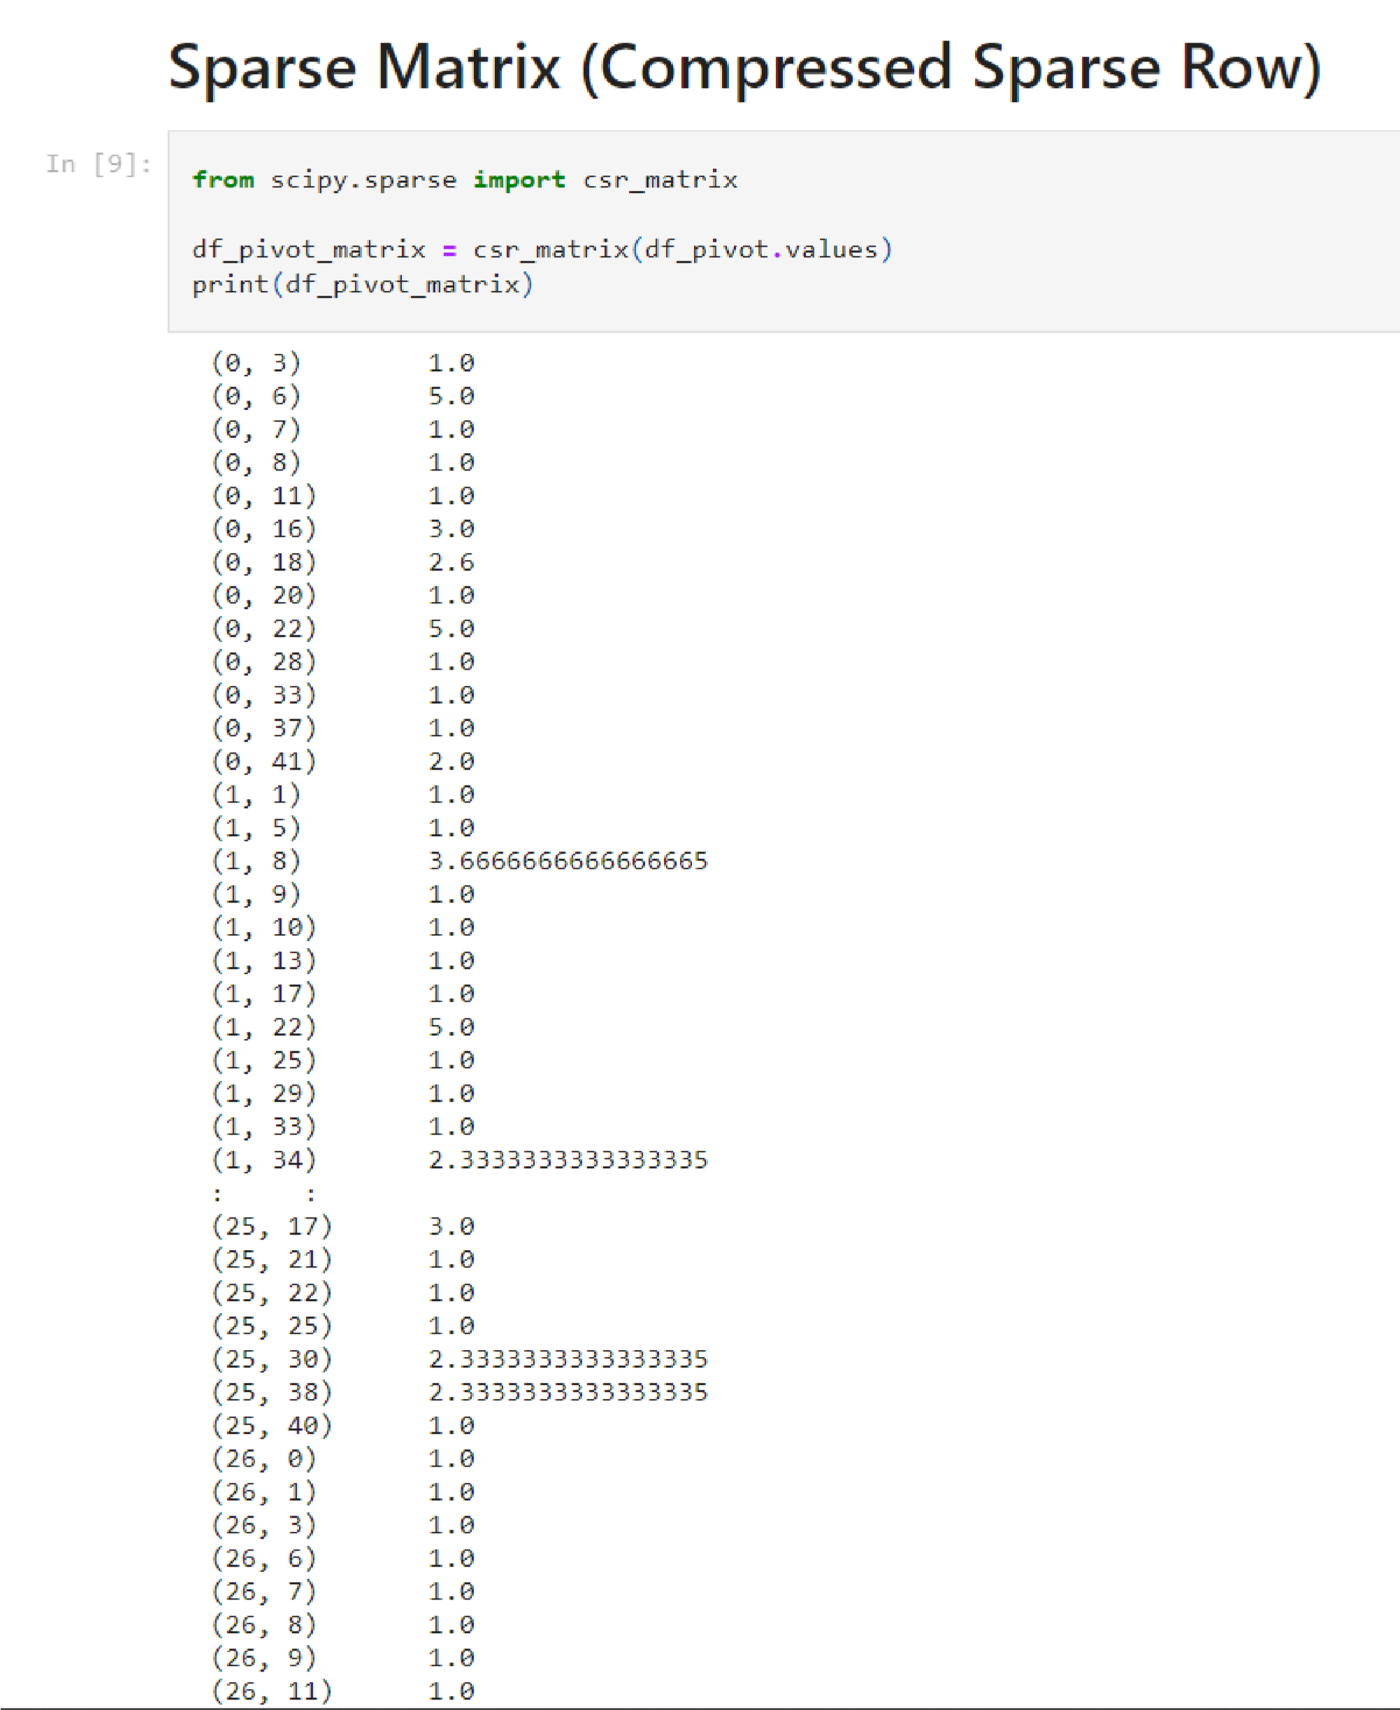

# SUPPLYING DATA TO NEAREST NEIGHBOURS MODEL

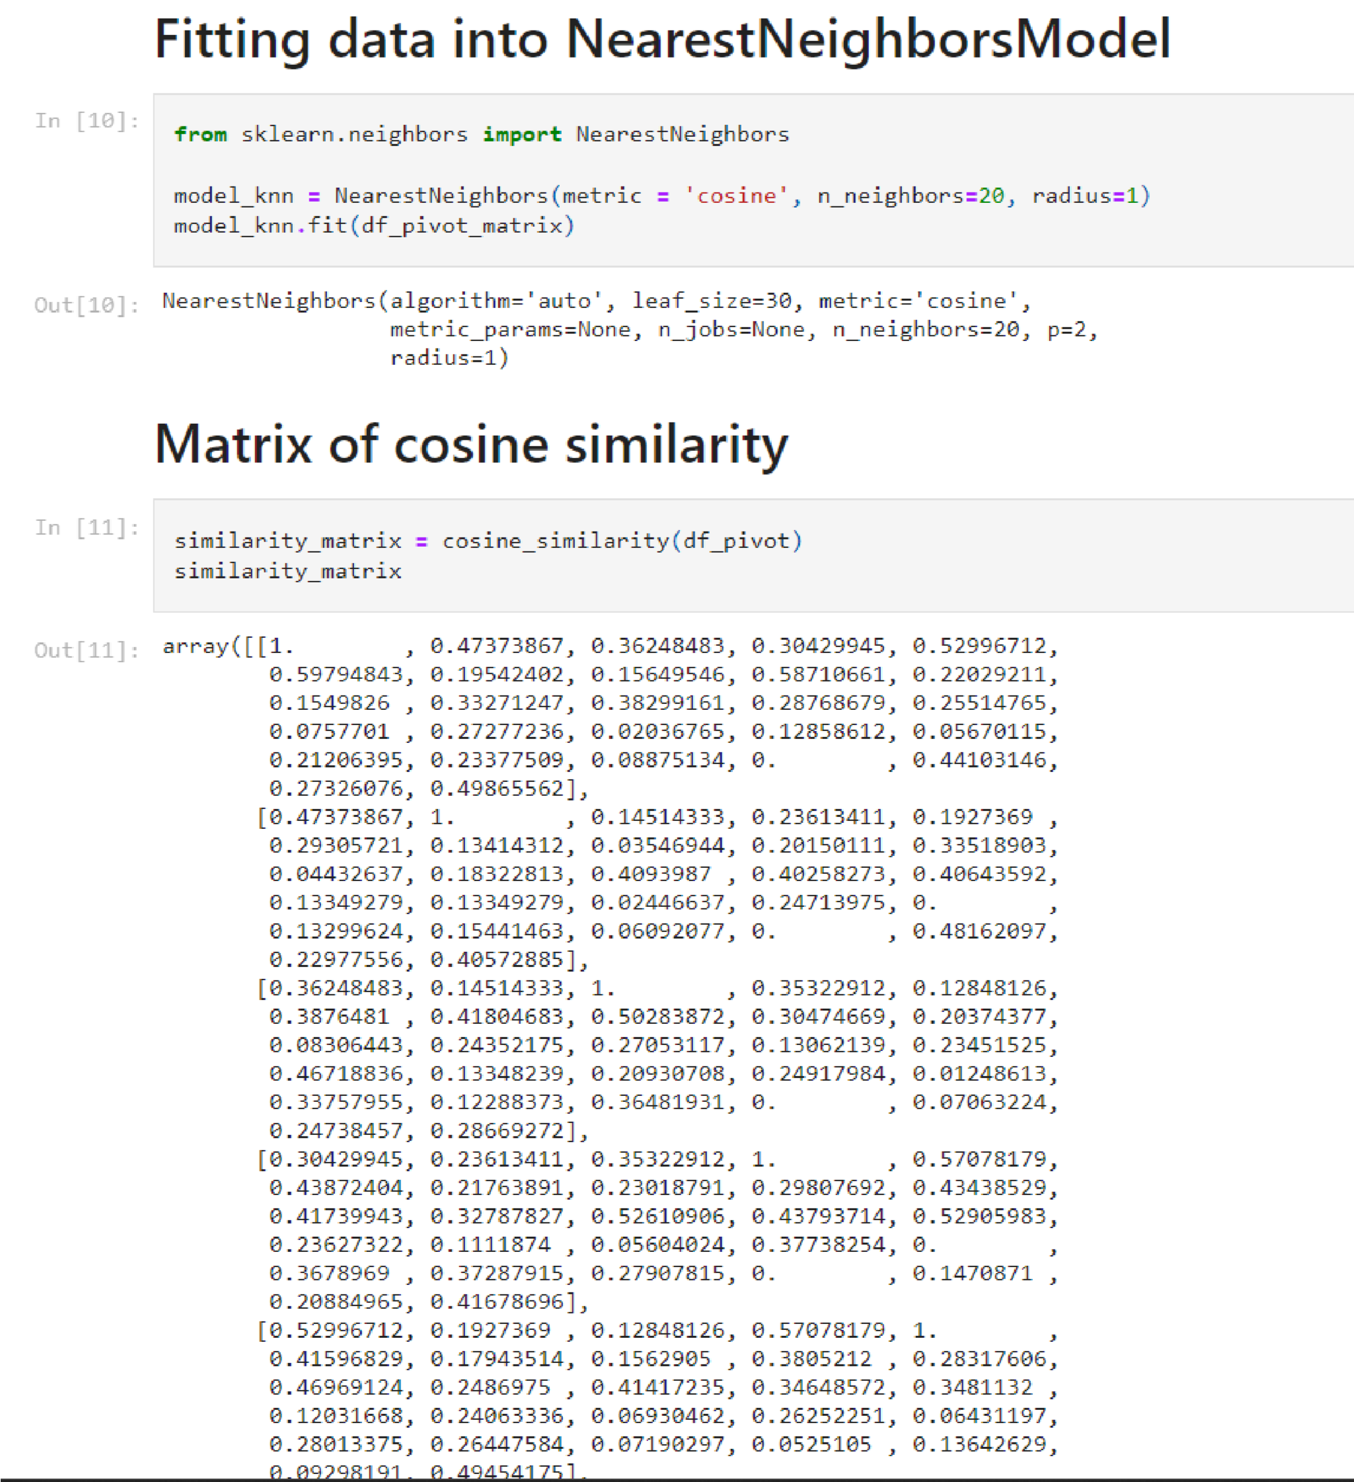

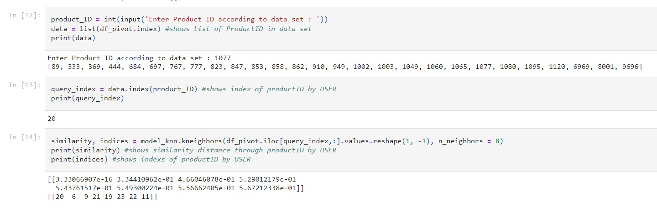

# CREATING DICTIONARY AND STORING RECOMMENDATIONS

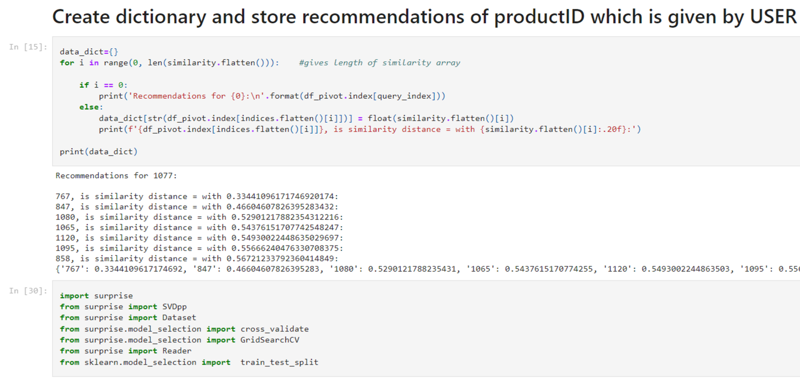

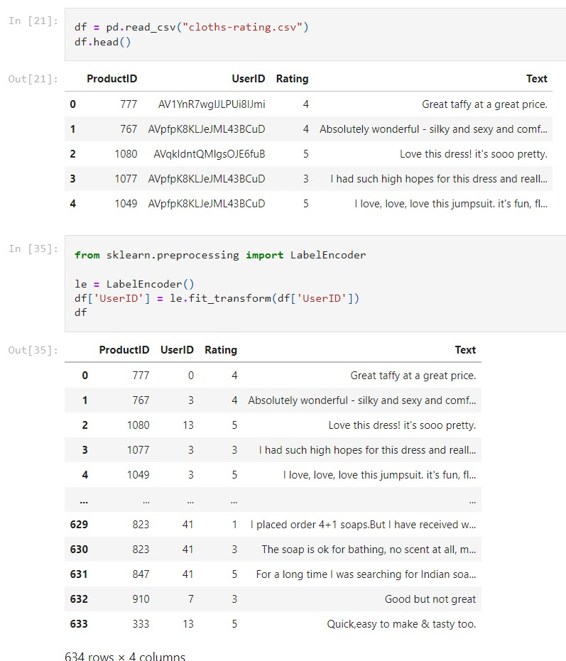

# FITTING MODEL AND PREDICTING THROUGH MODEL

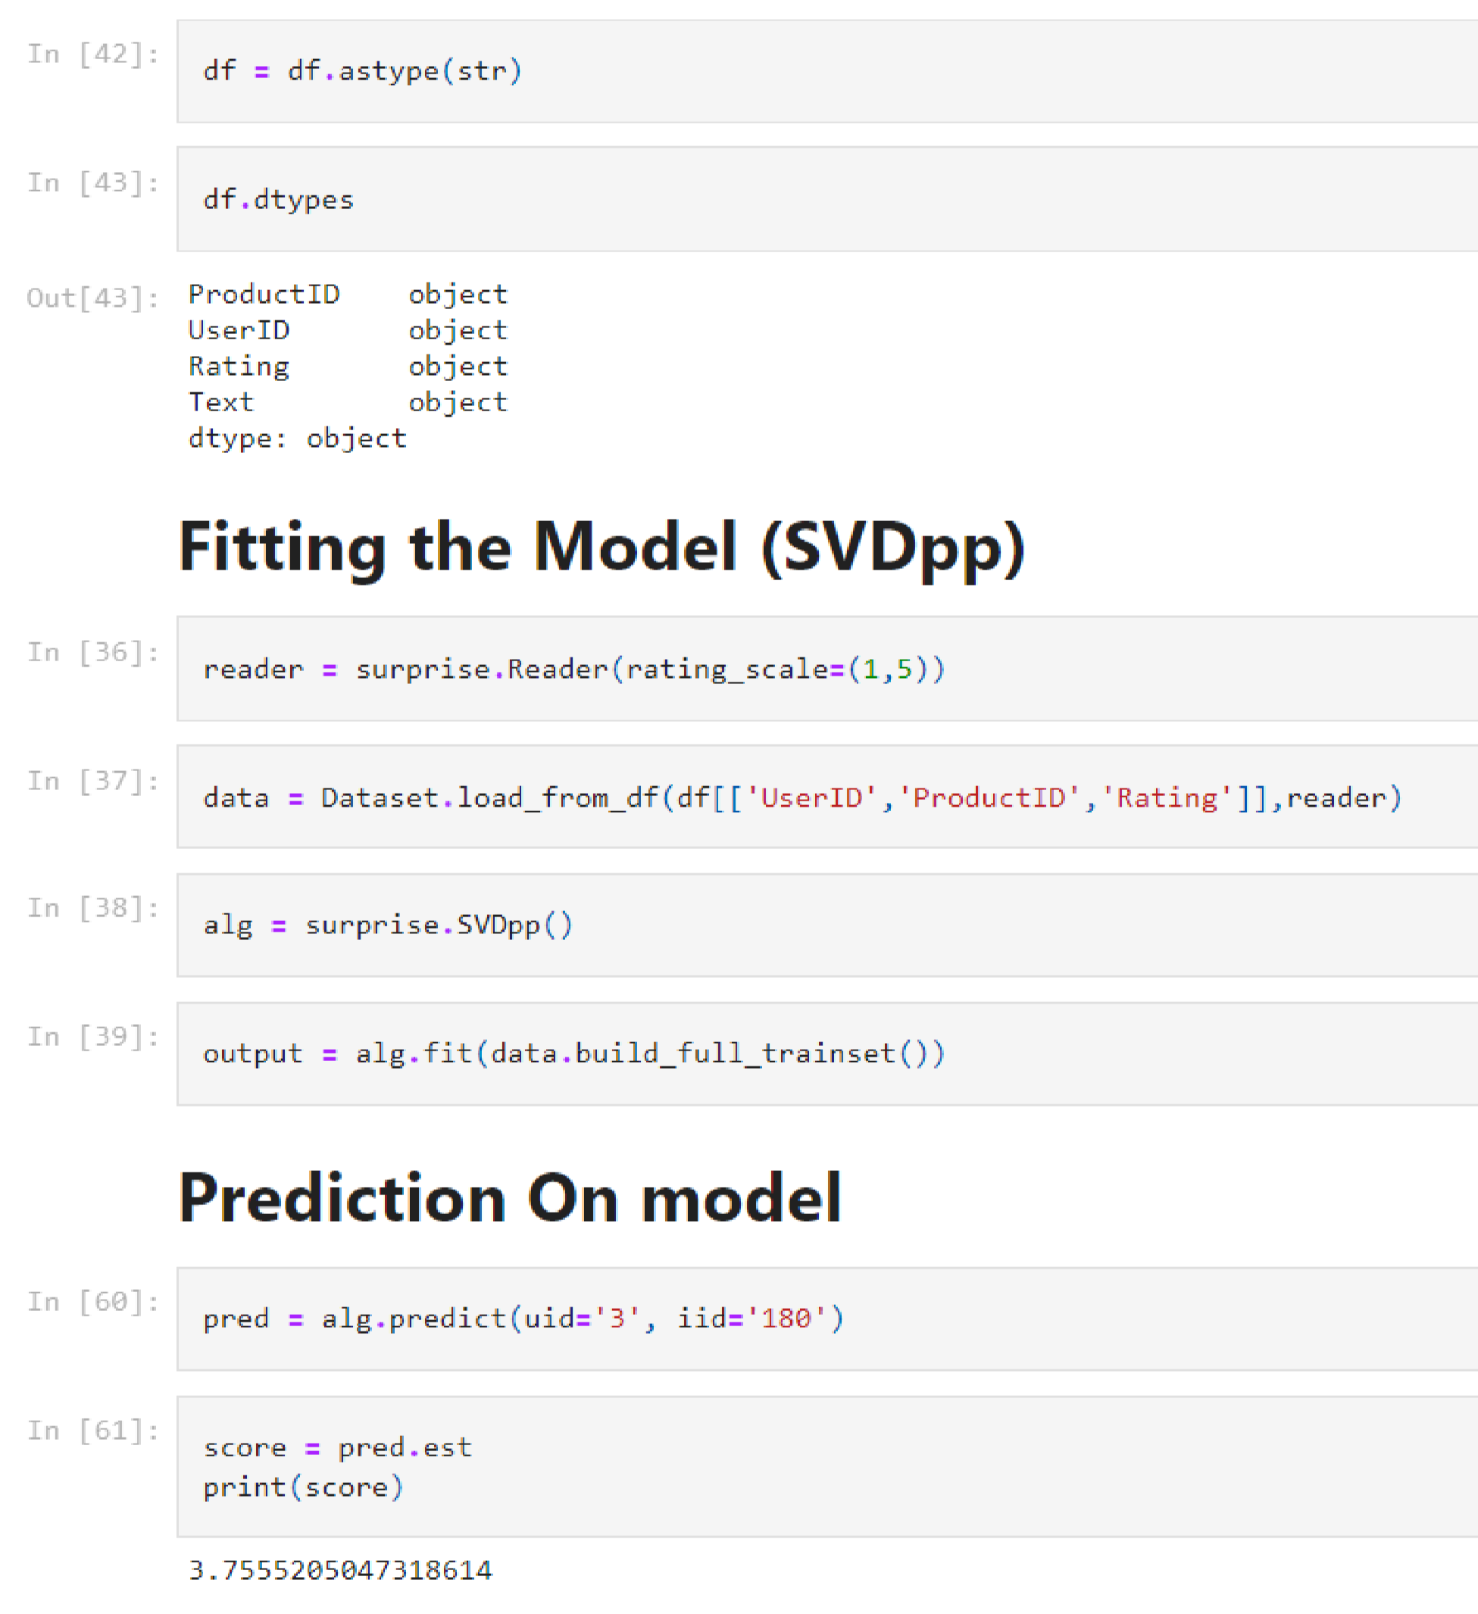

# TUNING & EVALUATING THE MODEL

